Name: __________________________ Class Period____________

Newton’s Laws of Motion Poster Project
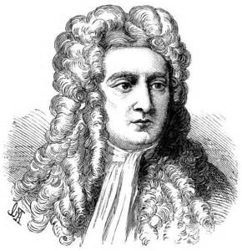
Due Thursday
October 27, 2016
Sir Isaac Newton lived during the 1600s, and he made observations about the world around him. Building on what his predecessors Aristotle and Galileo observed, Newton set down observations about motion and forces. His observations have been supported by more and more data over time; we call these Newton’s Laws of Motion. These laws of motion explain rest, constant motion, accelerated motion, and describe how balanced and unbalanced forces act to cause these states of motion.
Newton’s Three Laws of Motion
- An object in motion will stay in motion and an object at rest will stay at rest unless acted on by an unbalanced force.
- The force of an object is equal to its mass times its acceleration.
(F=m X a)
- For every action, there is an equal and opposite reaction.

What to do:
1. Illustrate an example of each of the three laws of motion.
2. Use one poster board or large piece of paper. (One poster should have 3 illustrations!!)
3. You may draw, use photographs, or use images from magazines or the internet.
4. Include an explanation of how the illustration demonstrates or describes the law of motion. Put the explanation next to the illustration. Do not use a separate sheet of paper for the explanation.
5. Make sure your illustrations are colorful and neat.

Grading:
•This will count as a TEST GRADE!!
(Test grades count as 40% of the total grade in class.)
• Your illustrations and explanations will be graded based on the rubric (on the back of this sheet)

Newton’s Laws of Motion Poster Project
Due Thursday 10-27-16

70  Content and Accuracy | 50 | 40 | 30
All written information is accurate | All written information is accurate | Written information is partly accurate | Written information is inaccurate
Illustration is accurate | Illustration is accurate | Illustration is partly accurate | Illustration is inaccurate
No errors in illustration or explanation | No major errors in illustration or explanation | Noticeable errors in illustration or explanation | Major errors in illustration or explanation
Written information is complete | Written information is mostly complete | Written information is mostly complete | Written information is incomplete
Illustration is complete  Visual Appeal | Illustration is mostly complete | Illustration is mostly complete | Illustration is incomplete
30 | 20 | 10 | 0
Colorful | Colorful | Colorful | No Color
Eye-appealing | Eye-appealing |  | Poster torn and/or dirty
No obvious eraser marks or White-Out | Small eraser marks or White-Out  Obvious | Obvious eraser marks or White-Out | Large amounts of eraser marks or White-Out

