Name: ________________________________ Class Period: ____

Dynamic Earth Web Quest
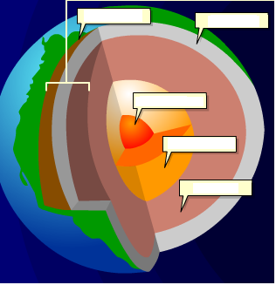
Go to: http://www.learner.org/interactives/dynamicearth/index.html
Click on “Start your exploration into Earth’s Stucture”

Earth’s Structure:
Mouse over the diagram to respond to the following questions
1. What is the thickness, in miles, of the following layers:
a) Crust: _______________ under oceans & __________ thick under continents.
b) Mantle: ______________
c) Outer Core: ____________
d) Inner Core: _____________
2. Label the diagram of Earth to the right
3. Describe the Lithosphere: __________________________________________________________________________________________________________________________________________________________________________
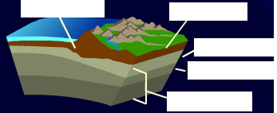
4. Describe the Asthenosphere:____________________
________________________________________________________________________________________________________________________________________________________________________________________
Plate Tectonics:
5. The Theory of Plate Tectonics is attributed to German scientist ______________________________.
6. The original large land mass or “Supercontinent” is referred to as ___________________ which is Greek for “______________________________”.
7. Complete the table:
200 million yrs ago | 135 million yrs ago | 65 million yrs ago | 50 – 40 million yrs ago
- _____________ begins to break up w/ _____________ in the North & _____________ in the South | - __________________ splits  - S. America/Africa separates from ________________ / ________________  - ______________ breaks away from Antarctica/Australia | - Laurasia begins to separate with _________________ & __________________ breaking apart  - S. America & Madagascar split from ___________________ | - ___________________ separates from N. America  - _____________ separates from ________________ & moves North  - Indian landmasses collide w/ _____________

8. Plate Tectonics Theory has been widely accepted since the ___________’s. It states that Earth’s outer layer or _________________ is broken up into ________________. These plates hold ______________________ and _____________________. They are constantly _________________.
9. Continents over time BONUS QUESTION: Since the plates are constantly in motion, scientists predict that 250 million years from now the continents will come together to for _______________________________________ called ________________ ____________________.
Plate Boundaries:
10. Continental crust underlies ______________________ and is _______________ miles thick,
whereas __________________________ is found under the ocean and is only ___________ miles thick.
11. Name the three types of plate boundaries below. Create a simple diagram of each including arrows to show the direction of their movement & list some examples of that type of boundary
_________________ Boundary | _________________ Boundary | _________________ Boundary
Diagram: | Diagram: | Diagram:
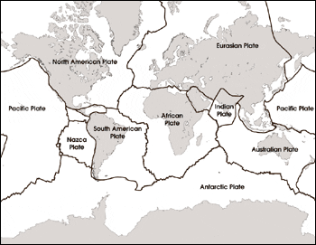
12. Use colored pencil or marker to
indicate the types of boundaries on the
map to the right. Create a key below:

Convergent

Divergent

Transform

Label the following plates on the map:
N. America Plate, Eurasian Plate, Pacific
Plate, Antarctic Plate, African Plate

13. How many plates did you place
correctly? __________ score

Slip, Slide & Collide
14. At convergent boundaries tectonic plates _________________________________

15. Roll over the diagram to define the following terms:
a) subduction zone: ___________________________________________________________________
_____________________________________________________________________________________ b.) trench: ___________________________________________________________________________
c.) volcanoes: ________________________________________________________________________
_____________________________________________________________________________________
d.) tsunami:___________________________________________________________________________
_____________________________________________________________________________________
16. Mountain range in Asia that was formed by colliding tectonic plates: ________________________. This mountain range continues to grow by ______ inch(s) per year.
17. At divergent boundaries tectonic plates are __________________________________________.
18. What is Sea Floor Spreading? _________________________________________________________
_____________________________________________________________________________________
19. Volcanoes form in both _______________________ and _________________________ boundaries.
20. At transform boundaries tectonic plates _____________________________________________.
21. A crack or fracture in Earth’s crust is a ________________________.
22. Explain what causes earthquakes. Provide a detailed answer & include the terms: tectonic plates & stress in your response. _________________________________________________________________
__________________________________________________________________________________________________________________________________________________________________________
23. What type of fault is the San Andreas Fault in California? _________________________________
24. The San Andreas fault runs between the _________________________ & ___________________ plates and is approximately _____________ miles long.
25. Interactive Quiz: Plate Interactions Challenge – What was your best Score? ________

TEST SKILLS: Complete this section and be prepared to print PAGE 1 ONLY of the Results page when you finish.

You answered _______ out of 30 questions correct. Your score was _______%

