Ms. Stanford
7th Grade Science 1st Semester Study Guide
**Please use this study guide along with your notes and or textbook**

Scientific Method & Engineering Design Process- Chapter 1
• Scientific methods are the ways in which scientists follow steps to answer questions and solve problems.
• You should know the steps of the scientific method and what each part means, for example “What is a hypothesis?”
Measurement and Safety- Chapter 1
• Scientists use a variety of tools to measure and analyze the world around them. The International System of Units (SI) is a simple, reliable, and uniform system of measurement that is used by most scientists.
• You should know what the graduated cylinder, beaker , balance and spring scale measures.
• Before starting any science activity or science lab, review the safety symbols and the safety rules for that activity or lab. Don’t take chances with your health and safety.
Laws of Motion- Chapter 20
• You should know the laws of motion and be able to recognize examples of each law.
• Objects at rest will not move unless acted upon by an unbalanced force.
• Newton’s second law is represented by the following equation: F = m × a.
• Newton’s third law of motion states that whenever one object exerts a force on a second object, the second object exerts an equal and opposite force on the first object.
Speed and Motion- Chapter 19
• Velocity is speed in a given direction.
• Acceleration is the rate at which velocity changes.
• You should be able to calculate speed and velocity if given the equation. S= D/T
Simple Machines- Chapter 21
• In scientific terms, work is done when a force causes an object to move in the direction of the force.
• Work is calculated as force times distance. The unit of work is the joule.
• You should know the six simple machines and be able to identify examples of each.
Transverse and Longitudinal Waves- Chapter 22
- You should know the definition of each wave
- You should be able to identify parts of each wave , such as the crest, trough, amplitude etc.
- You should know the definition of the different parts of the wave.
Layers of the Earth- Chapter 15
- Four major layers of Earth. Crust, mantle, outer core, inner core
- Five physical layers of Earth.
- You should know the physical composition of each layer. For example, the outer core is made mostly of liquid iron and metal.
- Mantle makes up 67%, Crust less than 1% and core roughly 33%
Tectonic Plates- Chapter 15
- You should know which layer is made up of the tectonic plates
- What happens at or near the boundaries, such as geographical features formed from plate movement and that they move at cm per year.
- You should know the three types of boundaries, convergent, divergent and transform.
Convergent- collide, forms mountains
Divergent- separate, sea floor spreading, mid ocean ridges
Transform- slide past each other, earthquakes
Minerals- Chapter 13
- Definition of a mineral
- 4 requirements of a mineral
- 7 physical properties used to identify minerals
Rock Cycle- Chapter 14
- Definition
- Major processes that causes formation of the 3 major types of rocks.
Natural Resources- Chapter 18
- Definition of natural resource, nonrenewable, renewable and conservation
Cells- Chapter 2
- Definition of cell
- Organelle structure/ function of plant and animal cells p. 62
- Major differences between plant and animal cells
Sample Questions

____ 1. A scientist is unable to speak or move most of the muscles in his body. This scientist uses his cheek to push buttons on a type or keyboard that translates the words into a computerized voice. Which of these best describes the scientist’s device?
a. | assistive, because the device makes the scientist famous | c. | adaptive, because the scientist can use the device for other tasks
b. | assistive, because the device enables the scientist to communicate | d. | adaptive because the scientist can still move some parts of his body

____ 2. A student draws and labels the parts of an animal cell, as shown below. What organelle is labeled incorrectly?
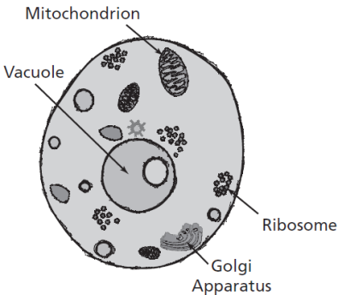
a. | mithochondrion | c. | vacuole
b. | golgi complex | d. | Ribosome
____ 3. Which diagram best represents particle movement in a transverse wave?
a. | 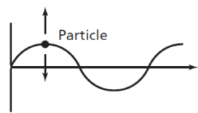 | c. | 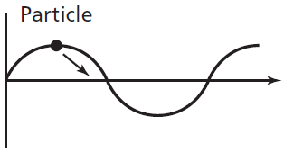
b. | 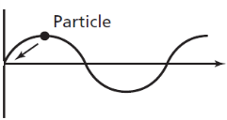 | d. | 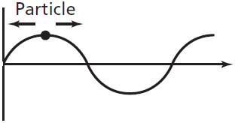
____ 4. What is smallest unit that can perform all the processes necessary for life?
a. | cell | c. | organelle
b. | nucleus | d. | protist
____ 5. Which example best describes Newton’s third law of motion?
a. | when a glass slid across a table, it spilled water when it stopped suddenly | c. | when a passenger stepped from a boat to the shore, the boat moved away from the shore.
b. | an engine used less work to move a lighter car than when it moved a heavier car | d. | A bowling ball rolled in a straight path when it was thrown towards bowling pins.
___ 6. Which is the most likely effect of a rise in global temperatures caused by human activities?
a. | rising sea levels | c. | fewer tropical storms
b. | more earthquakes | d. | increased soil erosion
____ 7. A students rode a bicycle 15 miles in 1.5 hours. What was the student’s average speed?
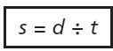
a. | 10 mph | c. | 16.5 mph
b. | 13.5 mph | d. | 22.5 mph
____ 8. Technicians plan to develop a new type of keyboard that will have alphabet letters in different positions from a standard keyboard. Which will best help the technicians decide if the new keyboard is an improvement over the standard one?
a. | asking people their opinions of how they like standard keyboards | c. | determining how much it will cost to make a new keyboard
b. | analyzing the problems that people have using standard keyboards | d. | comparing the speeds at which people type on each style of keyboard
___ 9. In eukaryotic cells, which organelle contains the DNA?
a. | nucleus | c. | smooth ER
b. | Golgi complex | d. | vacuole

____ 10. Which geological feature was most likely formed when two lithospheric plates collided?
a. | Lake Michigan | c. | Mississippi River delta
b. | Grand Canyon | d. | Sierra Madre mountain range

____ 11. A portion of a human arm works as a simple machine.Which simple machine is most like a human arm?
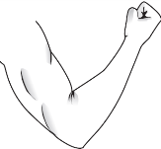
a. | a lever | c. | an inclined plane
b. | a wedge | d. | a screw
____ 12. How much force was applied to a box that required 45 joules of work to push it up a
3-meter-long ramp?
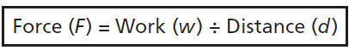
a. | 15 newtons | c. | 48 newtons
b. | 42 newtons | d. | 135 newtons
____ 13. The Himalaya Mountains formed from a collision of the Indo-Australian plate with the Eurasian plate. Which best approximates the rate of movement of the Indo-Australian plate?
a. | 0.67 millimeters per year | c. | 6.7 meters per year
b. | 6.7 centimeters per year | d. | 67 meters per year
____ 14. What part of the cell forms a barrier between the cell and its environment?
a. | cell membrane | c. | ribosome
b. | nucleus | d. | cholesterol
____ 15. Students were studying how temperature affects water movement. The students added drops of food coloring to different temperatures of water. They measured the rates at which the food coloring spread throughout the water. Which tools would best help the students complete their investigation?
a. | beaker, thermometer, stopwatch | c. | spring scale, thermometer, stopwatch
b. | meter stick, thermometer, beaker | d. | graduated cylinder, thermometer, balance
____ 16. Which organ system is correctly matched with its main function?
a. | The excretory system defends the body from disease-causing organisms. | c. | The skeletal system distributes energy throughout the body.
b. | The nervous system controls body responses to the environment. | d. | The digestive system removes waste products from the body.
____ 17. Which of these is the most likely unintended consequence of using ethanol made from corn as a replacement for gasoline in automobile engines?
a. | a reduction in the use of nonrenewable fuels | c. | a decrease in the amount of farmland available to produce food crops
b. | lower emissions of sulfur and nitrogen compounds in auto exhaust | d. | lower fuel costs for consumers
____ 18. Which best describes one way igneous rocks form?
a. | sedimentary rocks erode | c. | metamorphic rocks are melted, then cooled
b. | sedimentary rocks are compacted | d. | metamorphic rocks are deposited and cemented
____ 19. As a wavelength decrease, the crests of the wave
a. | become wider | c. | get closer together
b. | become shorter | d. | get farther apart
____ 20. Ribosomes, the organelles that make proteins, are found on the membranes of the
a. | cell wall. | c. | mitochondria.
b. | endoplasmic reticulum. | d. | vacuoles

____ 21. A cell is shown in the diagram below. What organelle is identified by the X?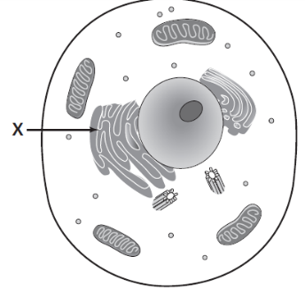
a. | centriole | c. | golgi apparatus
b. | ribosome | d. | endoplasmic reticulum

____ 22. Students were observing a green, odorless mineral, with no visible crystals The mineral was very soft, with a slick feel. They compared its characteristics to the table below. Which of these were the students most likely observing?
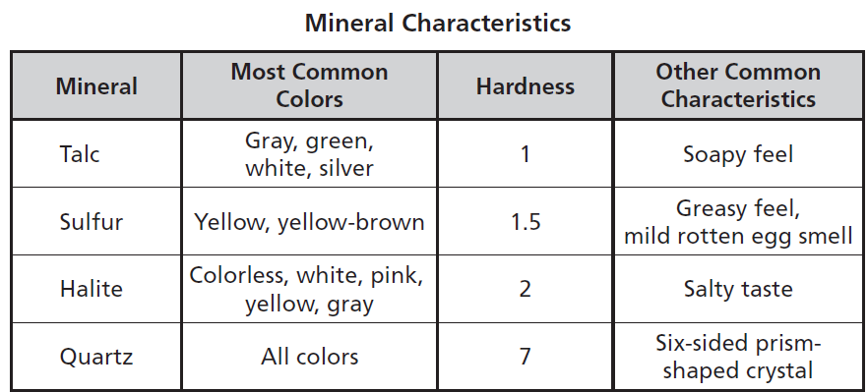
a. | Talc | c. | Halite
b. | Sulfur | d. | Quartz

____ 23. 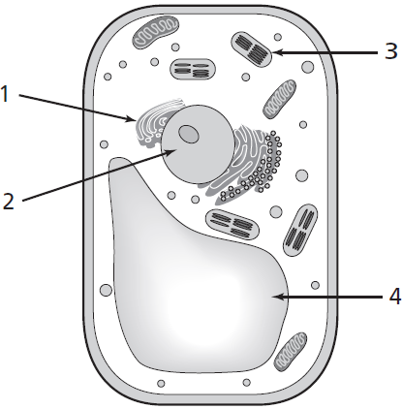
Which organelle captures an absorbs sunlight?
a. | 1 | c. | 3
b. | 2 | d. | 4

____ 24. The chart shows some levels of organization in an organism. Which term best completes the chart?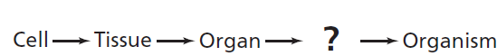
a. | Organelle | c. | Muscle
b. | Organ System | d. | Chemical

____ 25. Which of the following organelles can be found inside both plant and animal cells?
a. | E.R, golgi complex, chloroplast | c. | cell wall, nucleus, cytoplasm
b. | nucleus, cytoplasm, cell membrane | d. | chloroplast, golgi complex, nucleus

