Work and Simple Machines TCAP Review Packet

1. A shovel is shown below. A shovel is made up of two different simple machines. **The blade of the shovel acts as one type of machine as it separates soil when it enters the**

**ground. The handle of the shovel acts as a second type of machine when the person using it lifts the soil. What two simple machines make up a shovel?**

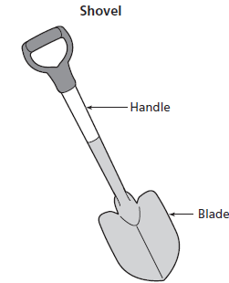

**A** pulley and wedge

**B** screw and inclined plane

**C** lever and pulley

**D** wedge and lever

1. **A lever and an inclined plane are shown below. Which of these best describes a function of these simple machines?**

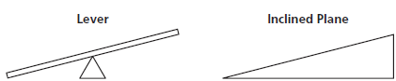

**A** They both can overcome friction with a rolling motion.

**B** They both can secure two parts of an object together.

**C** They both can separate two parts of an object.

**D** They both can help raise objects from the ground.

1. A student uses a lever to apply a 20-newton force to a box while moving the box a distance of 0.5 meter. **How much work did the student do while moving the box? W= F x D**
2. 10 joules
3. 40 joules
4. 100 joules
5. 400 joules
6. **Work is performed by a lever when a load (L) of 5 newtons is applied at one end, as shown below. Using the formula, what force (F) is required to make the lever balanced?**



1. 5 newtons
2. 10 newtons
3. 20 newtons
4. 40 newtons
5. **A student needs to move a heavy object across 50 meters of level ground. Which simple machine will most help the student move the object?**

**A.** lever

**B.** screw

**C.** inclined plane

**D.** wheel and axle

6. **A student applied a force of 30 newtons to pull a wagon a distance of 10 meters in the direction of the applied force.** Work**(***w***)=**Force**(***F***)×**Distance**(***d***)**

**How much work did the student do on the wagon?**

**A** 3 newton-meters

**B** 20 newton-meters

**C** 40 newton-meters

**D** 300 newton-meters

7. **A portion of a human arm works as a simple machine. Which simple machine is most like a human arm?**

**A** a lever

**B** a wedge

**C** an inclined plane

**D** a screw

8. **How much force was applied to a box that required 45 joules of work to push it up a**

**3-meter-long ramp?** Force (*F*) = Work (*w*) ÷ Distance (*d*)

**A.** 15 newtons

**B.** 42 newtons

**C.** 48 newtons

**D.** 135 newtons

9. **A student performed 50 joules of work by raising an object 2 meters with a pulley.**

**What was the force on the object? F= W/D**

**A.** 25 newtons

**B.** 48 newtons

**C.** 52 newtons

**D.** 100 newtons

10. **A logger splits a piece of wood with an axe. What simple machine splits the wood?**



**A** wedge

**B** wheel and axle

**C** pulley

**D** lever